# 

# **.** Part 2

**Prof. Nikolay TONTCHEV, D. Sc., Ph.D**

The purpose of this paper is to present the capabilities of the approach for analysis and multi-criteria optimization of quality indicators, changing from several identical (same) parameters operating in a certain interval.

The approach I present to you is appropriate for the design phase of various new, unsettled processes.Their technological parameters change in a certain range.Through the approach one or more sets of technological parameters can be determined to be experimentally tested when specifying the technology of the test item. The desired complex of properties depends on certain combinations of the technological parameters. The idea is that this complex is optimal. Since there are several properties, the optimization procedure is a multi-criteria one. From the set/expected values ​​of the criteria/properties, a procedure is performed which determines the combinations of technological parameters that can realize it. After the numerical experiment, it is determined whether the property values ​​can be improved or reached.

Sometimes different combinations have different energy-intensive content. This opportunity, like checking software, is very valuable in terms of energy saving.In this way the approach can be attributed to innovative instruments. The approach is characterized by the user friendly attitude of making the optimal decision. The solution takes into account which optimal complex of properties to what combination of parameters corresponds. This combination of parameters is recorded in the technological documentation and it is executed during the technological mode.

The user friendly approach is very valuable because with respect to all properties, the analyzes and the comparisons are carried out in the same dimensionless proportions (percents). Five variable percentage ranges are available that can be expanded or narrowed, depending on the decision maker’s wishes.Through this movement to the ‘top’ – the 100%, the boundaries of the variables are fixed up in several iterations, thus reaching the optimal solutions. An example of how the approach works in the 2D/two-dimensional case is illustrated by the following figures. For comparison, conventional graphical images are also shown, from which it is also possible to trace the veracity of the solution.





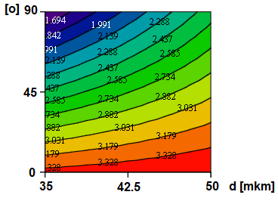 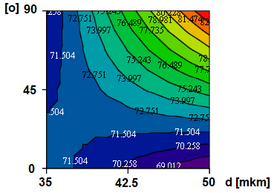

There are two models and their graphical images, through countur lines with Mathcad and our author’s approach. The selected visualization models can be multi-criterially optimized because the maxima and minima of the two models occur for different values of the control parameters that define the horizontal and vertical axis of variations.

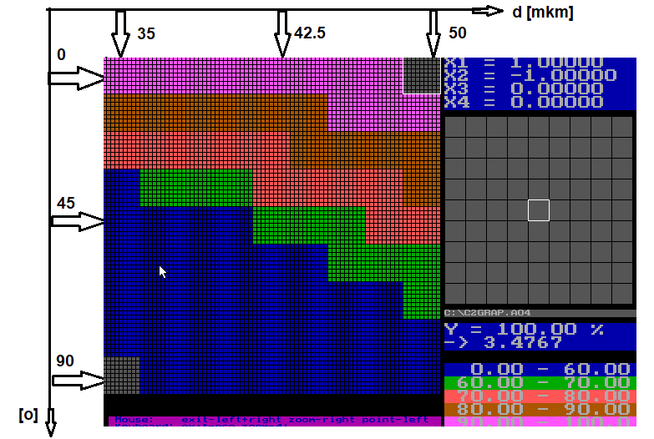 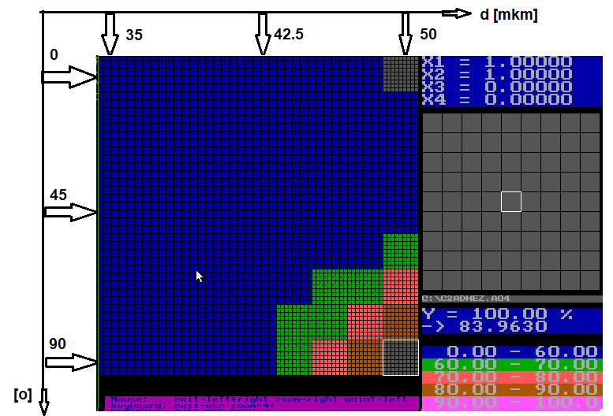

The optimization problem that is defined is to determine the control process parameters, the minimal first property and the maximal second property. From the graph of the presented solution it is clear that the optimal solution starts at a thickness of 42.5 at 90 degrees and that it is over 64% for the two explored values. Because the minimal value is sought for one of the properties, the solution found to be minimal is less than 36% (100-64%).

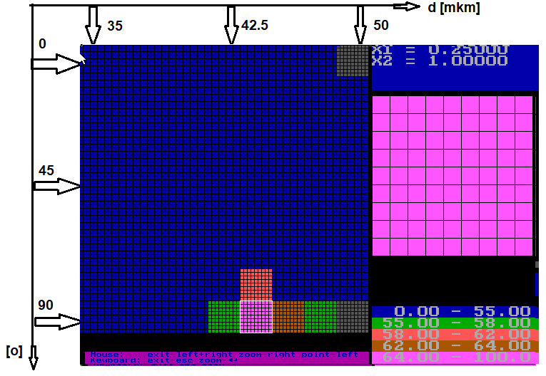

With the design adopted in the defining area defined by the control parameters, 81 states are controlled (92, where 2 are the parameters and 9 are the nodes in which the test parameter is controlled). As impressed by these 81 squares, in these 81 squares there are another 81 states (92) in the case that the parameters are 4, not [just] 2. Then globally in the domain there are changed: the first (horizontally) and the second (vertically); locally changes the third (horizontally) and the fourth (vertically).

An example of an image of a three-parameter model is presented as follows:

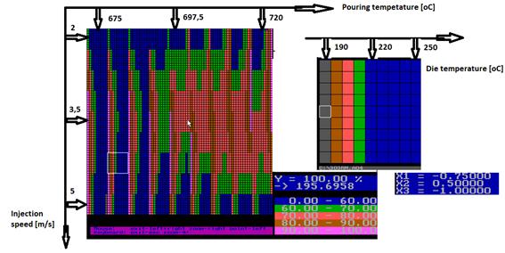

The peculiarity of it is that the local image in the small square on the right does not occur; the third parameter is treated as 9 striped rectangles instead. They also have squares inserted because of the possible inclusion of the fourth parameter. Here are two selected images with the fourth parameter included with the same color distribution of the color scales. In the fixed position of the first and second parameters of the four-factor model (the white square), a contour diagram is constructed for the third and fourth parameters.

 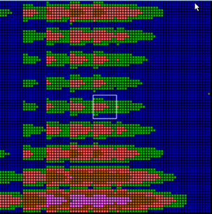 

The software automatically changes the coloring in the percentage intervals and there can be observed/read the real and the normalized values of the explored quantities with two pair of scrolling tools (one for the global location and the other for the local one). This task is a problem for analyzing the value of the explored quantity from the influence of the four technological parameters.

The optimization problem is solved in the space of the technological parameters and not as in the traditional approaches in the criteria plane. This is the reason for the user-friendliness of the analysis.

Three optimization solutions are presented in the figure, in which the ordering in the achieved requirements between the studied criteria is different.

The decision maker selects the corresponding control parameters depending on his/her own considerations. The case is two - dimensional. It is the same mechanism also for multi-parametric cases.

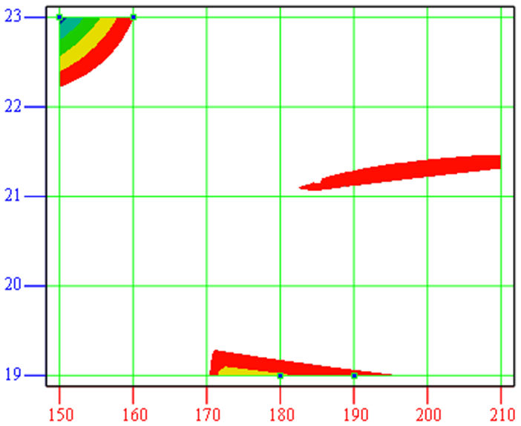

Initially, by refining /localizing at percentage intervals/, the decision is directed to fixing the global coordinates. After the global coordinates have been fixed, the local situation of the others, which are arranged in color, is taken into account. The choice of one or other global coordinates is again carried out by the decision maker (DM), for example by economic or environmental considerations. A graphical demonstration of the multicriteria optimization method to maximize two criteria/properties in the criteria space in several iterations is discussed below.

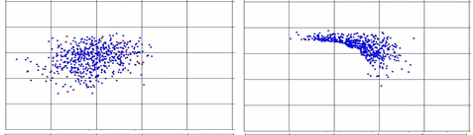

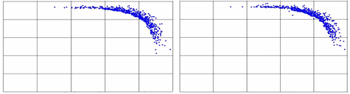

In the criteria space, Pareto’s front is being built. The inconvenience of this approach is the set of the decisions that are subsequently sought by an evaluation system on which the decision maker (DM) can recommend a solution. For this reason, we have abandoned and do not use the criteria space.

Recently, the neural approximation is much more valued rather than the regression.

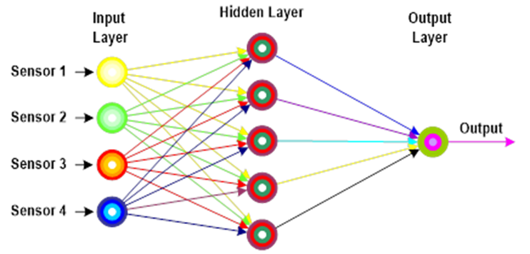

Our explanation for this is that in some cases there is a substantial difference between the predicted and the real value. Although the presented approach is set for regression approximations, the idea can be applied to a neural approximation, having the know-how about it. Besides, the software is constructed for up to four parameters. But we have developed a paper that develops the idea of ​​analysis and optimization with up to 10 technological control[ling] parameters. By normalizing /aligning them to an even percentage scale/ of the predicted values ​​of the models, all inaccuracies are ignored and only the tendency of the model can be worked out, and the predicted values ​​are for reference.

The presented approach, which is being discussed, monitors the whole area of ​​the explored property in the change of all control[ling] parameters with a certain step.

When a complex of properties must be explored, each property can be analyzed separately by the controlling technological factors and then the conditions of the complex forming properties are defined.

It is obligatory to set the identifier of each property that determines whether the researcher is interested in the minimal, maximal or values ​​of the relevant criterion in the complex.

## Conclution

The achieved results give grounds for future active international cooperation with scientific and production institutions for which a specific scientific product has been created and tested. The elaborated scientific product is a set of numerical methods beyond the scope of the originally intended application only for metallurgical and metalworking production. The developed methods are evaluated with the benefits of the relevant area. In the references, results have been achieved for saving materials and energy while maintaining the same level of quality indicator. This also indirectly reflects on the environmental protection. The importance of my research has been underpinned by the universality of the approach, and it has been developed for models of regression analysis and the artificial neural networks. Thus, a valuable and up-to-date methodology, thoroughly endorsed in a scientific style, has been apportioned and implemented.

References:

1. <https://www.researchgate.net/publication/316889741_Principle_of_operation_and_applications_of_the_MADMML_software>
2. <https://www.researchgate.net/publication/309823792_GENERALIZED_ALGORITHM_FOR_NUMERICAL_ANALYSIS_AND_MULTICRITERIA_OPTIMIZATION_OF_MULTIPARAMETRIC_REGRESSION_MODELS>
3. <https://www.researchgate.net/publication/265292354_BOOK_with_methods_to_metallurgical_design_alloys_-_httpswwwmorebooksdestoregbbookmaterials-science-effective-solutions-and-technological-variantsisbn978-3-659-22604-5>
4. <https://www.researchgate.net/publication/321492511_APPLICATION_OF_CAD_DESIGN_OF_TECHNOLOGICAL_PROCESSES_IN_THE_FIELD_OF_MATERIAL_SCIENCE>