Basic information

It has been proven that support for decision-making also exerts an important impact on the design process. The timeliness of this activity is determined on the basis of the benefits achieved, as in any other optimization process. Unlike classical optimization, technical decision making takes place under more than one criteria, with a different number of control parameters. For this reason, our team has built several software applications to support the process of this application from engineering practice. Our development activity has been running for more than fifteen years. For this period of time there have been solved applied problems in the field of casting, thermal and chemical-thermal processing and the restoration of worn surfaces by welding and coating
The software is extremely useful in exploring a set of quality indicators, as in the material science is the complex of properties after applied processing. Processing parameters are process input control parameters, and quality indicators are output controlled reactions. Multicriteria optimization defines these process modes of the research process, for which the user has explicitly defined certain preferences of the quality indicators.

Key characteristics

The algorithm that is being offered is not complicated. It is related to multicriterial support for making technical decisions. The algorithm analyzes and optimizes parameters after an engineering experiment. Since actual experimental data is used, if the models obtained prove the necessary checks, it means that the models are adequate and the forecasts obtained are reliable and can be used in engineering practice. The analysis that is applied is user-friendly. This analysis is valuable because it provides solutions for multifactor processes. Various alternatives can be evaluated. So far, software has been developed for two, three and four control parameters in the research of various selected technical quality parameters. In the future, under the proposed algorithm, there is an idea to develop further the number of the control parameters up to ten parameters describing the technological regime.
The number of developed four parameter control can be considered as optimal. For problems with more established influences, they can be transformed and solved in steps / parts.

The suggested analysis is valuable at the following two points:
1) Specialized software can process simulation test results and thus it can be used as a hybrid method in CAD / CAE systems in designing technological processes.
2) It can be determined from the set of obtained solutions the most acceptable one in terms of economy of the spent energy or the raw material during the experiment. This realized energy or raw material savings is applied after an acceptable solution has been obtained from the set quality parameters.
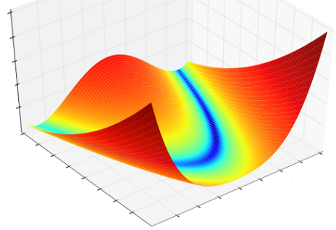
Indeed, how is this approach applied to energy and materials savings? Among the many technologies investigated with the software, a chemico-thermal process was developed to improve the working properties of heat-resistant steels. Several solutions with a desired set of properties have been identified to solve the problem. This is characteristic of any multi-criterion task. Each particular solution corresponds to different modes that vary considerably over the duration of the process or the pressure of the used gas. Thus, among these solutions, a mode with a shorter chemico-thermal treatment time is chosen which is more energy efficient and less gas consuming. Thus, on the one hand, a compromise solution is established that satisfies all the quality indicators and, on the other hand, provides less energy or material consumption.

The optimization of th e complex of properties is accomplished through the multicriteria optimization module, which produces an effective solution. Any effective solution, by its very nature, can be innovative, too. Effective solutions are Pareto's solutions. These solutions are not improving optimal solutions. Strategies for determining effective solutions can be varied: average, geometric mean, and so on. Our approach uses the strategy of the pessimistic option. This strategy maximizes solutions in a generalized matrix containing the smallest value of the analyzed criteria.

Valuable analysis of multiparametric processes can be applied because the chosen approach takes place in the space of the variables. When displaying Pareto front solutions, the criterion /controlled parameters space is used. With this traditional approach, all effective solutions are built, for which a valuation system is hard to find, to offer a preferred solution.

The proposed algorithm in the variable space may also recommend a weak Pareto solution, but with a more substantial contribution to less energy-intensive and material-intensive solutions.

The performance of this analysis is possible because of the visualization of the decisions in the space of the control parameters. The investigated managed parameters are projected into the space of the technological modes of a certain color, which is determined by the corresponding value of the research parameter. The value of this parameter is normalized in the range [0-100%]. In this scale are set the intervals of the corresponding coloring. In this color variation, both the number of the respective colors can be chosen, so the interval of the respective colorings. This tool is also used in the regression model analysis phase, and at the multi-criteria optimization stage.

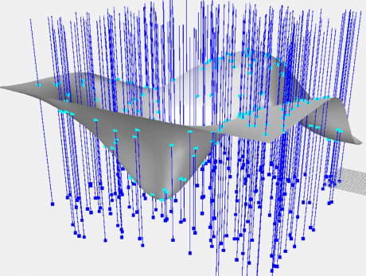
In the modeling area, at the stage of the regression model output, it is necessary to specify the connections between the control and the managed parameters as input data. They can be pre-planned or consecutively executed, unassigned in the so-called passive experiment. For a larger number of data processing observations, a different pattern structure can be applied. Each structure is evaluated with two estimates. The decision-maker chooses the best structure for these ratings. The structure determines the respective coefficients of the regression model. The determined coefficients define the magnitude examined. Several dimensions investigate define the criteria in the multi-criterion task, with preferences for them.

The approach is applicable to all processes with multiple adjustable parameters that vary in range. The variable range is scaled to nine steps in which all controlled control parameters are changed. For a number of 9⁴ combinations, if the parameters are four, the process under consideration fully analyzes 6541 combinations of control modes. For defined technical multi-criteria problems this proposed accuracy is quite satisfactory.

