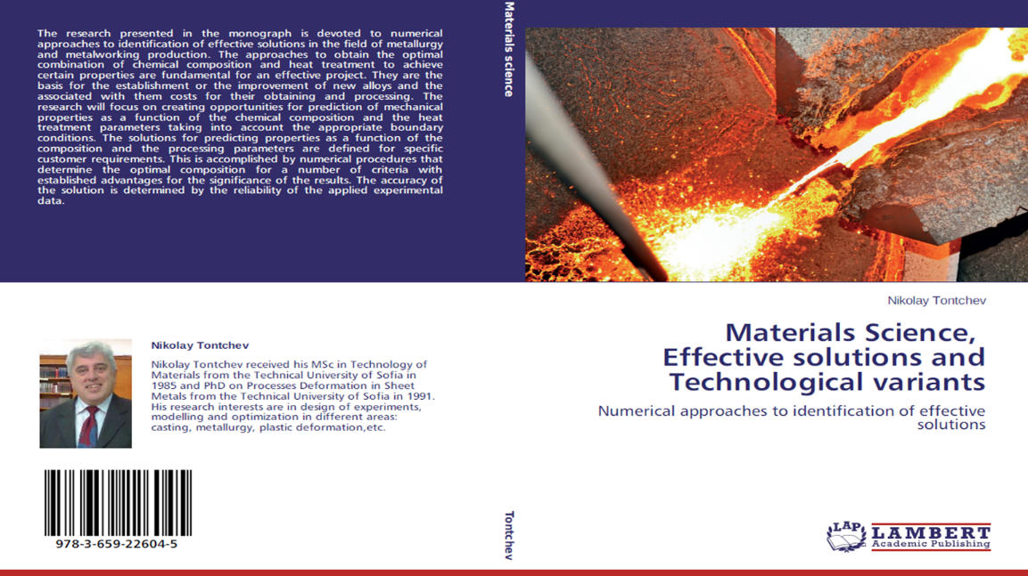
My second dissertation was related to the optimization of the chemical composition of steels in the heat-treated state – hardening and high-temperature recovery.
This research was published in Germany as my monograph.
In this monograph, most of my modern computational methods are found.

